A CRM APPLICATION FOR WHOLESALE RICE MILL

**CHINTAPALLI KUMAR RAJA : 21PA1A5715@VISHNU.EDU.IN**

1. **Project Overview :**

The Rice Mill CRM is a comprehensive solution designed to simplify the management of rice production and sales tracking. It facilitates daily reporting on the quantity and type of rice produced and sold, providing timely updates to the owners. This CRM focuses on customer relationship management to boost customer engagement, streamline operations, and enhance overall performance within the rice mill. The project aims to deliver a user-friendly application tailored to the specific functional requirements of a rice mill.

1. **Objectieves :**

**Business Goals:**

The Rice Mill CRM App will automate daily production and revenue reporting, offering owners clear insights into operational performance. It will also implement customer analytics to identify buying trends and popular rice varieties, enabling targeted marketing and improved customer engagement. Additionally, the application will streamline resource allocation by forecasting demand and analyzing sales patterns. This will help the business optimize inventory management and efficiently allocate resources.

**Specific Outcomes**:

The Rice Mill CRM App will automate daily production and revenue reporting, offering owners clear insights into operational performance. It will also implement customer analytics to identify buying trends and popular rice varieties, enabling targeted marketing and improved customer engagement.

1. **Salesforce Key Features and Concepts Utilized :**
2. **Reporting and Dashboards:** 
   * **Daily Sales and Production Reports:** The system generates detailed reports on the daily production and sales of rice.
   * **Revenue Reports**: Offers insights into the daily revenue generated.
   * **Customer Data Review**: Tracks popular rice varieties and the most frequent buyers.
3. **Resource dispersion**: Assists owners in understanding data for better resource distribution and future planning.
4. **Rollup Summary Field:** 
   * **Purpose**: These fields are used to perform calculations on the child object records and display the result on the parent object. You can sum up numerical data, count the number of child records, find the minimum or maximum value, or even calculate the average.
   * **Functions**: COUNT, SUM, Minimum, and Maximum functions.
5. **Cross-Object Formula Field:** 
   * **Purpose**: mention fields from another object in Salesforce.
   * **Function**: Calculates the total amount payable by procreate the number of rice units taken by the price per kg.

1. **proof Rules:** 
   * **Purpose**: Ensures data unity by confirming user inputs.
   * **Is Blank Formula**: Verifies if a field is blank and displays an error message if the rule returns a value of "True."
2. **Permission Sets:**

**Roles and Access**:

* + **Company Owner**: Can view records of employers and workers.
  + **Employer**: Can view records of workers.
  + **Worker**: Can view the records of customers.

**4. Detailed Steps to Solution Design :**

**Step 1: Creating Programmer Account :**

**Steps:**

1. Go to <https://developer.salesforce.com/signup>
2. On the sign up form, enter the following details :

[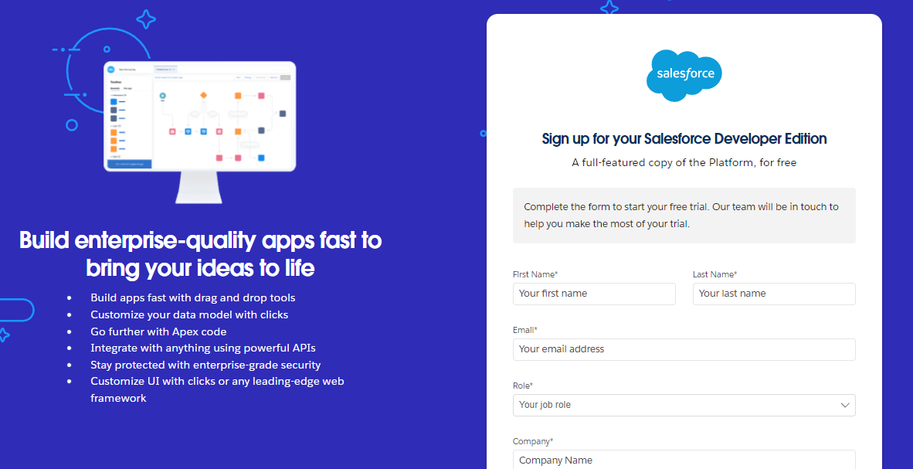](https://developers.salesforce.com/Signup*)

1. First name & Last name
2. Email
3. Role : Developer
4. Company : College Name
5. County : India
6. Postal Code : pin code
7. Username : should be a combination of your name and company

This need not be an actual email id, you can give anything in the format : username@organization.com

Click on sign me up after filling these.

**Step2 : Account Initiation :**

1. Go to the inbox of the email that you used while signing up. Click on the verify account to activate your account. The email may take 5-10mins.

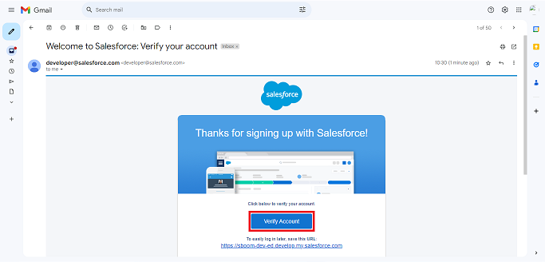

1. Click on Verify Account
2. Give a password and answer a security question and click on change password.

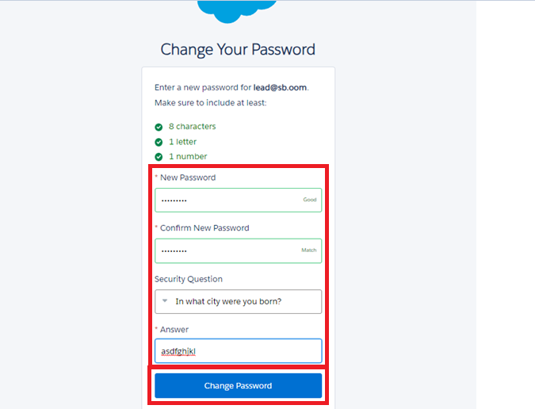

1. Then you will redirect to your salesforce setup page.

# Step 3: Objects

Salesforce objects are of two types:

1. **Standard Objects**: Salesforce.com provides standard objects, such as users, contracts, reports, dashboards, and more.
2. **Custom Objects**: Users create custom objects to supply unique and essential info for their agreement. These objects form the heart of any coating and provide a structure for sharing data.

**Steps:**

# Create Supplier Object

To create an object:

1. From the setup page >> Click on Object Manager>> Click on Create>>Click on Custom Object.
2. Enter the label name>>supplier
3. Plural label name>>supplier
4. Enter Record Name Label and Format

* Record Name >> supplier  Name
* Data Type>>Text

1. Click on Allow reports and Track Field History and allow search
2. Allow search >> Save.

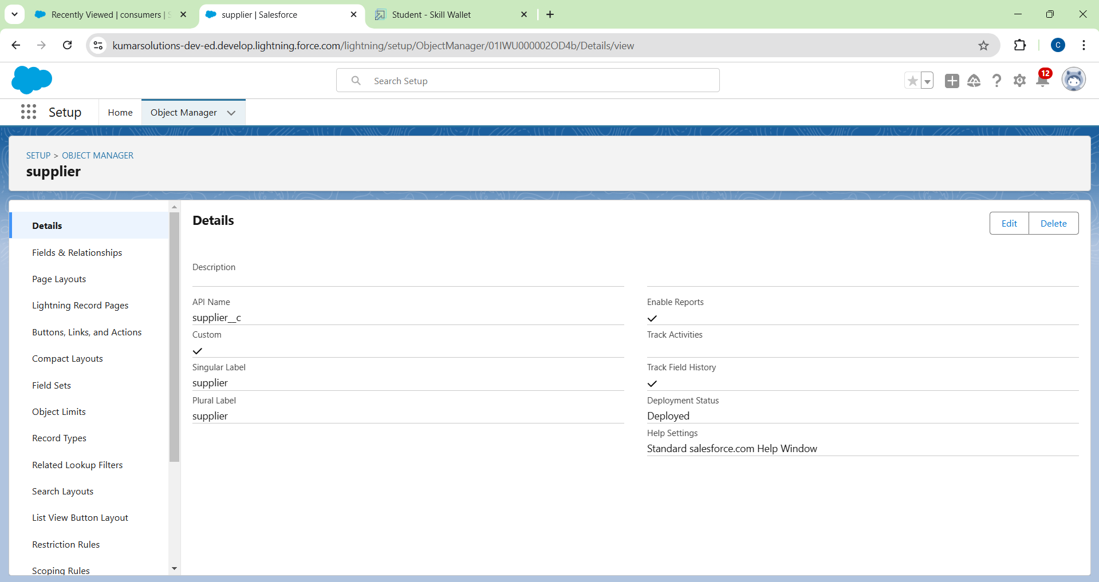

# Create Rice mill Object

To create an object:

1. From the setup page >> Click on Object Manager>>Click on Create >> Click on Custom Object.
2. Enter the label name>>rice mill
3. Plural label name>> rice mills
4. Enter Record Name Label and Format

* Record Name >>
* Data Type >> Auto Number
* Display Format >> rice-{000}
* Starting number >> 1

1. Click on Allow reports and Track Field History, Allow Search and Save.

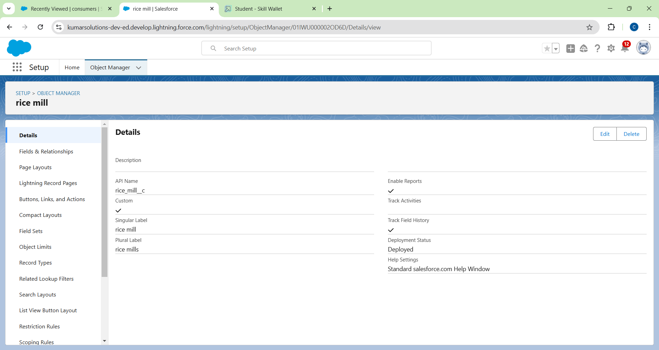

## Create consumer Object:

1. Use these display format for the  consumer

* label name >> consumer
* Plural label name >>  consumers
* Display Format >>  consumers-{000}
* Starting number >> 1

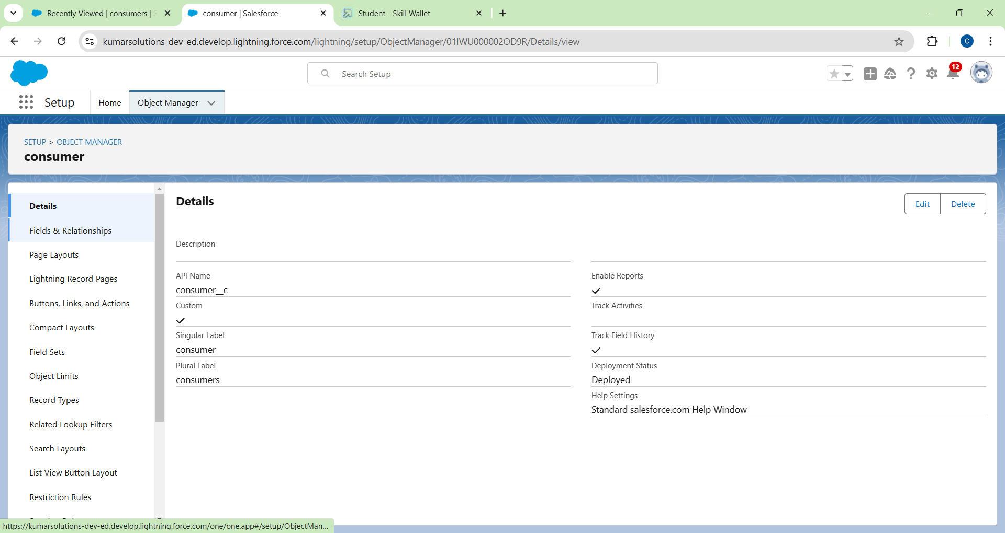

## Create rice details Object

1. Use these display format for the rice details

* label name >> rice details
* Plural label name >> rice details
* Display Format >> rice-{000}
* Starting Number >>1

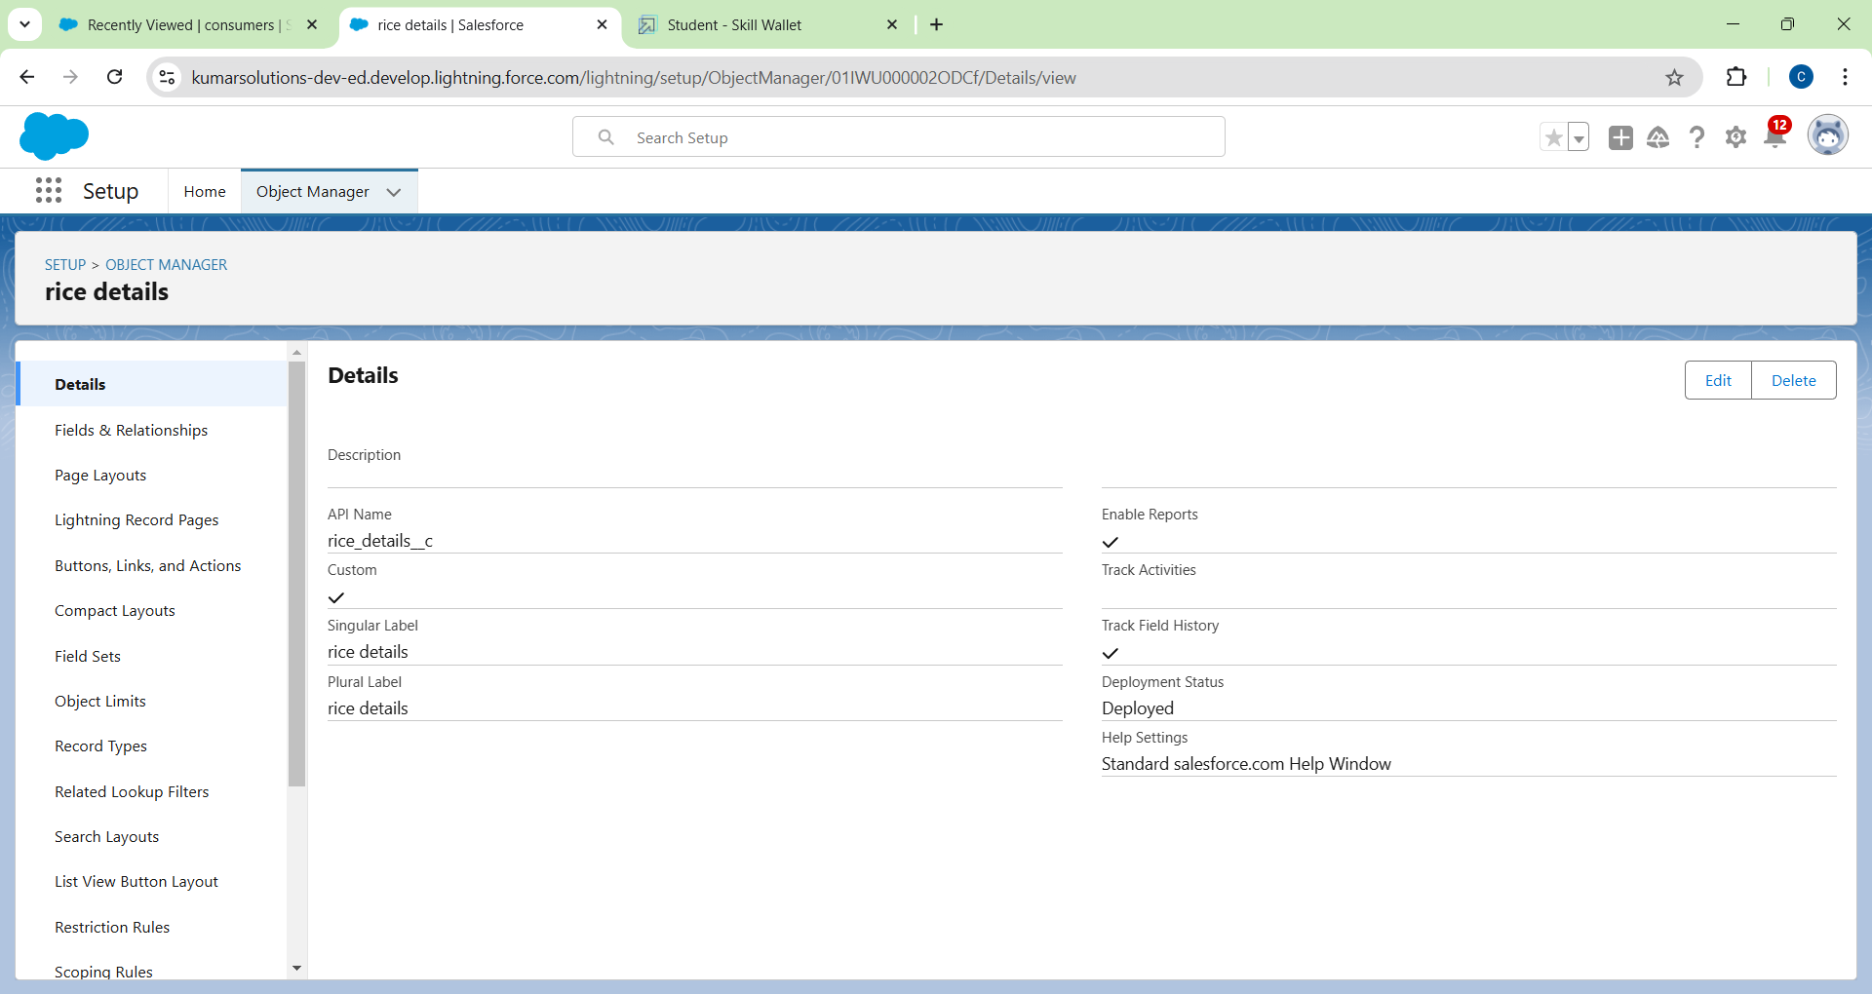

## Step 3: Tabs

To create a Tab:( supplier)

1. Go to setup page >> type Tabs in Quick Find bar >> click on tabs >> New (under custom object tab)

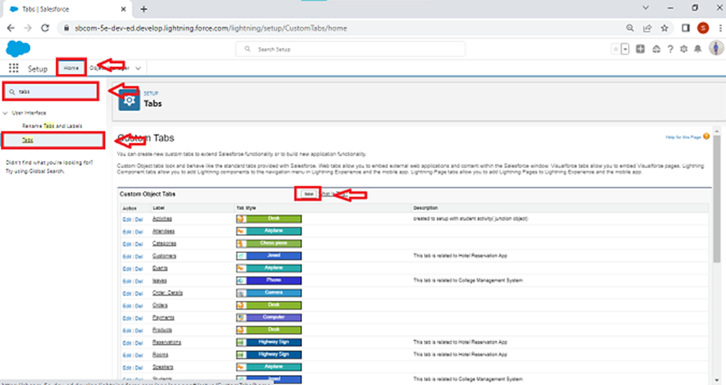

1. Select Object( supplier) >> Select the tab style >> Next (Add to profiles page) keep it as default >> Next (Add to Custom App)  uncheck the include tab .
2. Make sure that the Append tab to users' existing personal customizations is checked.
3. Click save.

**Creating Remaining Tabs**

1. Now create the Tabs for the remaining Objects, they are “ rice mill, consumer , rice details”.

**Step 4: The Lightning App**

## Create a Lightning App

To create a lightning app page:

1. Go to setup page >> search “app manager” in quick find >> select “app manager” >> click on New lightning App.
2. Fill the app name in app details as MY RICE >> Next  >> (App option page) keep it as default >> Next >> (Utility Items) keep it as default >> Next.
3. Upload a photo that is related to your app.
4. To add Navigation Item:
5. Select the items (supplier, rice mill, consumer , Rice details ) from the search bar and move it using the arrow button >> Next.
6. To Add User Profiles:
7. Search profiles (System administrator) in the search bar >> click on the arrow button >> save &
8. 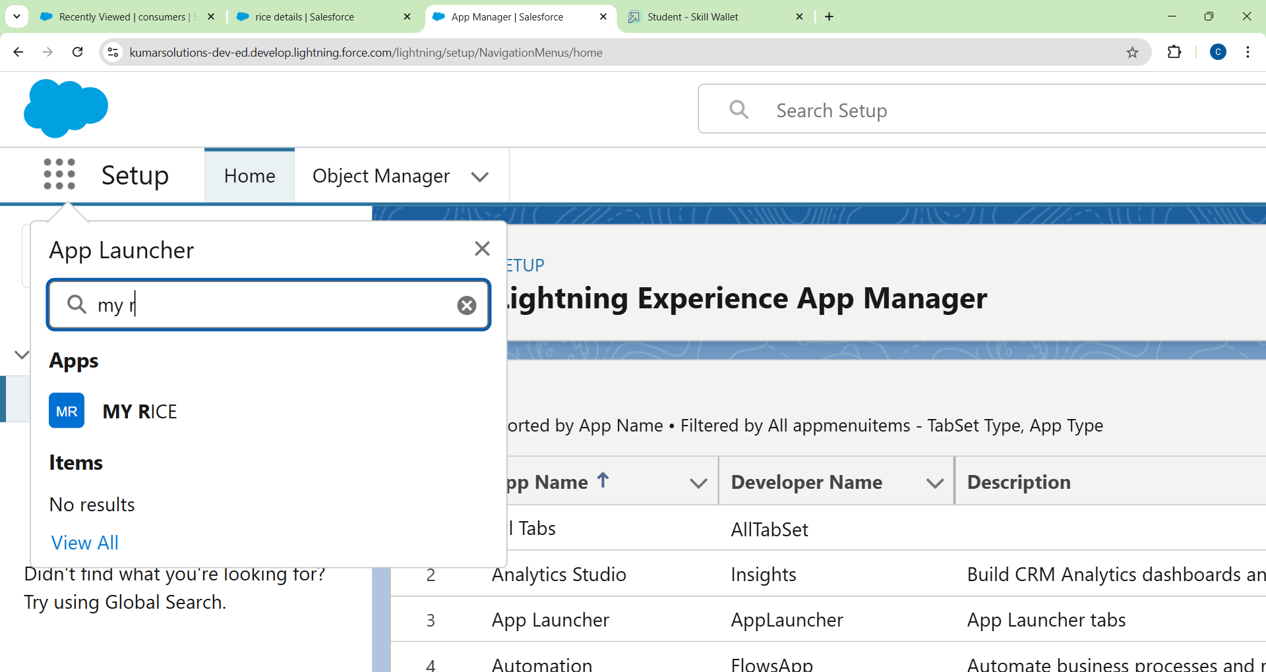

**Step 5: Fields**

**Creating the number field in rice details object**

1. Go to the setup page >> click on object manager >> From drop down click edit for  rice details object
2. Click on fields & relationship >> click on New
3. Select Data type as “Number” and click Next.
4. Given the Field Label as “ rice distributed ” and length as “ 5 ”.
5. Field Name will be auto populated, and click on Next- Next >> Save.

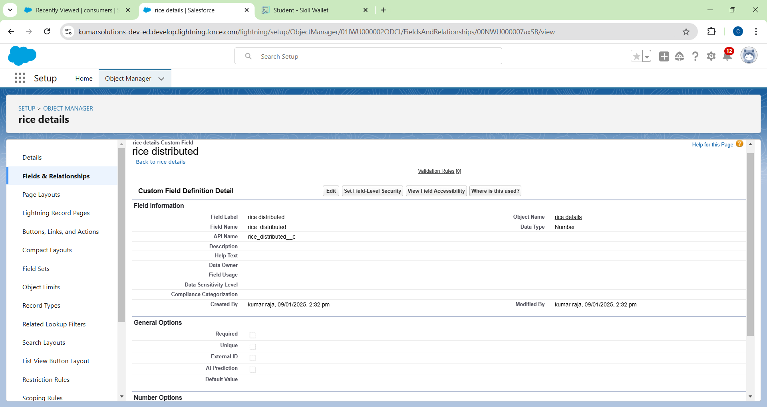

**Creating Junction Object:**

A Junction  object is a custom object that serves as a bridge between two related objects in a  many-to-many relationship. It allows you to create a relationship between records of two different objects by creating a many-to-many relationship model.

Creating junction object as rice details with supplier & rice mill

To create junction object

1.Go to the setup page >> click on object manager >> From drop down click edit for  rice details    object

2. Click on fields & relationship - click on New.

3. Select “Master-Detail relationship” as data type and click Next.

4. Select the related object “ supplier ” and click next.

5.Give Field Label as “supplier Name” and click Next.

6.Next >> Next >> Save & New.

7.Follow the same steps from  1 to 3.

8.Select the related object “ rice mill ” and click Next.

9.Give Field Label as “rice mill 1(one)” and click Next.

10.Next >> Next >> Save.

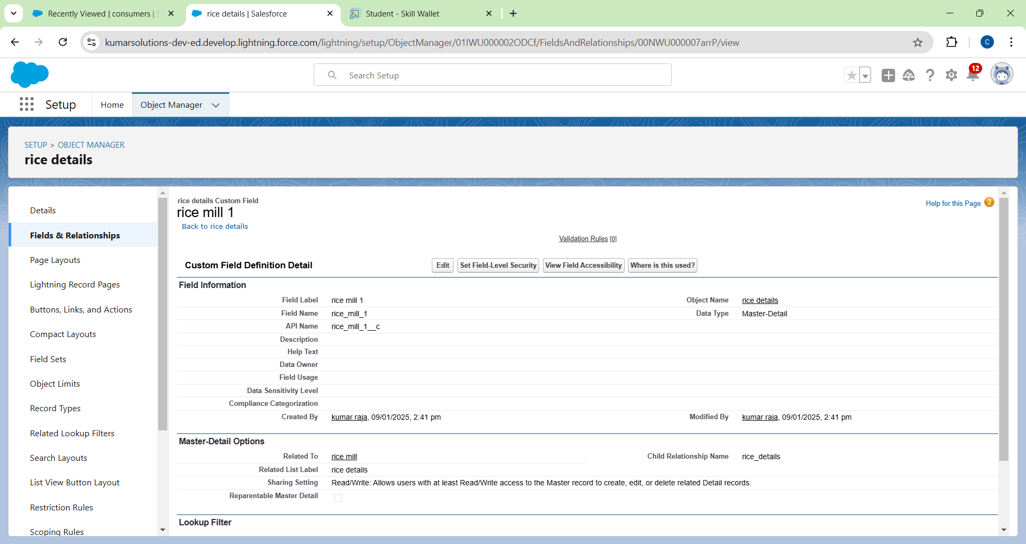

**Creating a Master-Detail Relationship**

master-detail relationship is a type of relationship between two objects where the master object controls certain behaviors and settings of the detail object. Here are a few use cases that demonstrate the use of master-detail relationships

Creating Master-Detail Relationship between consumer & rice mill Object

To Create a Master-Detail relationship

1. Go to the setup page >> click on object manager >> From drop down click edit for  consumer object.
2. Click on fields & relationship >> click on New.
3. Select “Master-Detail relationship” as data type and click Next.
4. Select the related object “ rice mill”.
5. Give Field Label as “rice mill name” and click Next.
6. Next >> Next >> Save.

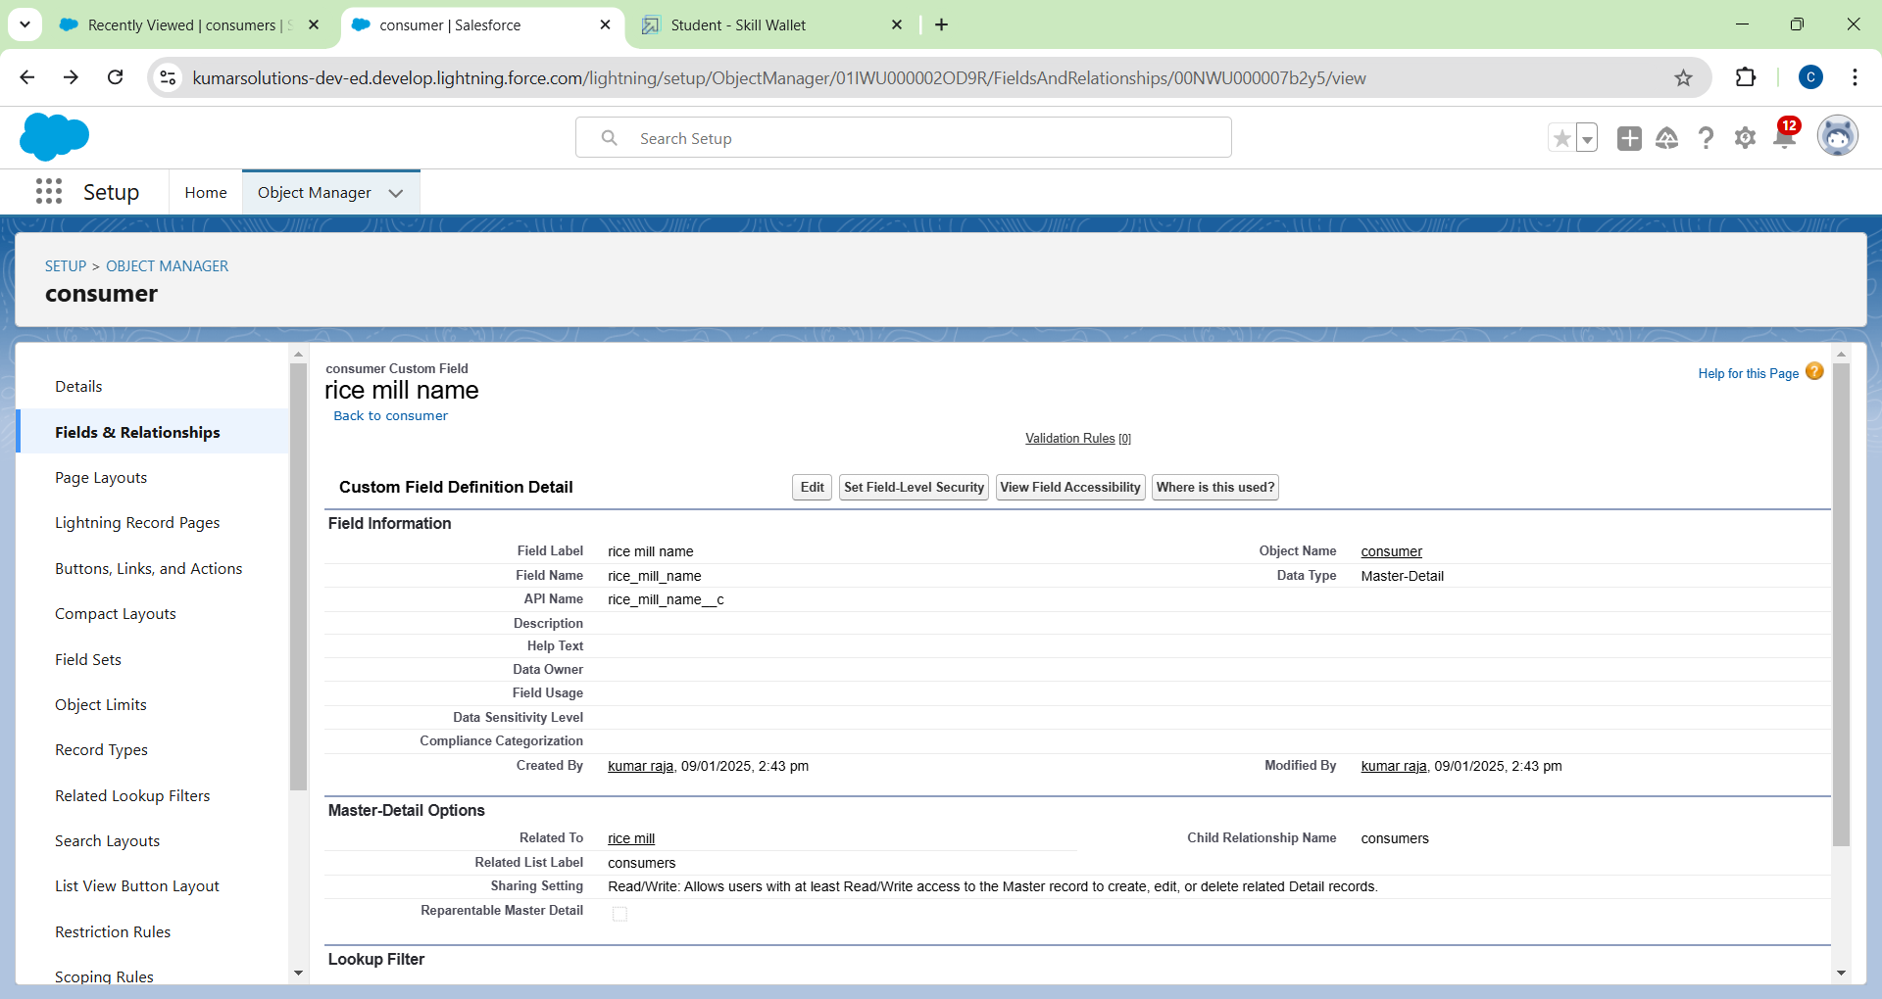

## Creating the Roll-up Summary

* Go to setup >> click on Object Manager >> type object name (supplier) in the search bar >> click on the object.
* Now click on “Fields & Connections” >> New
* Select the data type as “Rollup summary”, and click Next.
* Give the Field label as “sum of rice Shared", Field Name will be Auto brought forth, and click Next. Select the summarised object as “rice details”.
* Select the Rollup type as “sum”.
* Select the field to aggregate as “rice Shared”, and click Next >>Next >>Save
* Follow the same steps for the rice mill Object from 1 to 3
* Give the Field label as “rice Shared to shops”, Field Name will be Auto bring forth, and click Next.
* Select the summarised object as “rice details”.
* Select the Rollup type as “sum”.
* Select the field to aggregate as "rice Shared", and click Next >> Next >> Save.
* Note: create the field as “ rice taken by shops in kegs” using number datatype in consumer object
* Follow the same steps for the rice mill Object from 1 to 3
* Give the Field label as “rice taken”, Field Name will be Auto brought forth, and click Next.
* Select the summarised object as “consumer”.
* Select the Rollup type as “sum”.
* Select the field to aggregate as “rice taken in shops”, and click Next >> Next >> Save.

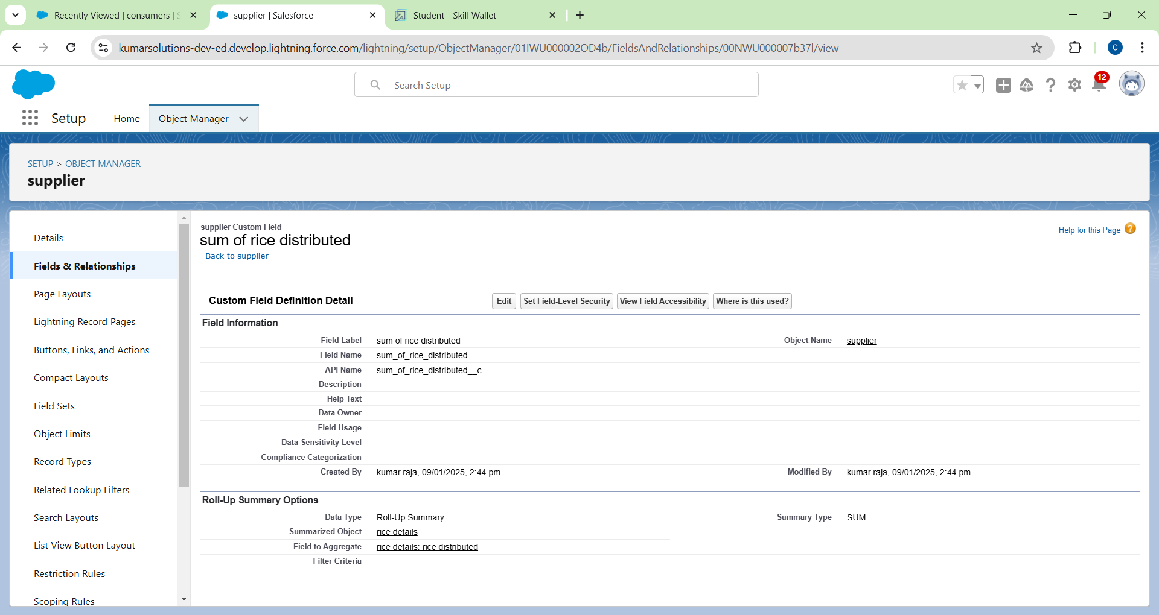

## Creating validation rule:

* Go to the setup page >>click on the object manager >> From the drop-down, click edit for consumer object.Click on the proof rule >> click New.

Enter the Rule name as “Phone number or email blank rule”.

* Enter the description as “phone number and email number should not be blank”.
* Enter the formula as “OR( ISBLANK( phone_number__c ) , ISBLANK( email__c ) )” and check the syntax.
* Under the error message, write as “please fill in your phone number.”
* Select error location “top of page”.
* Save the proof rule.

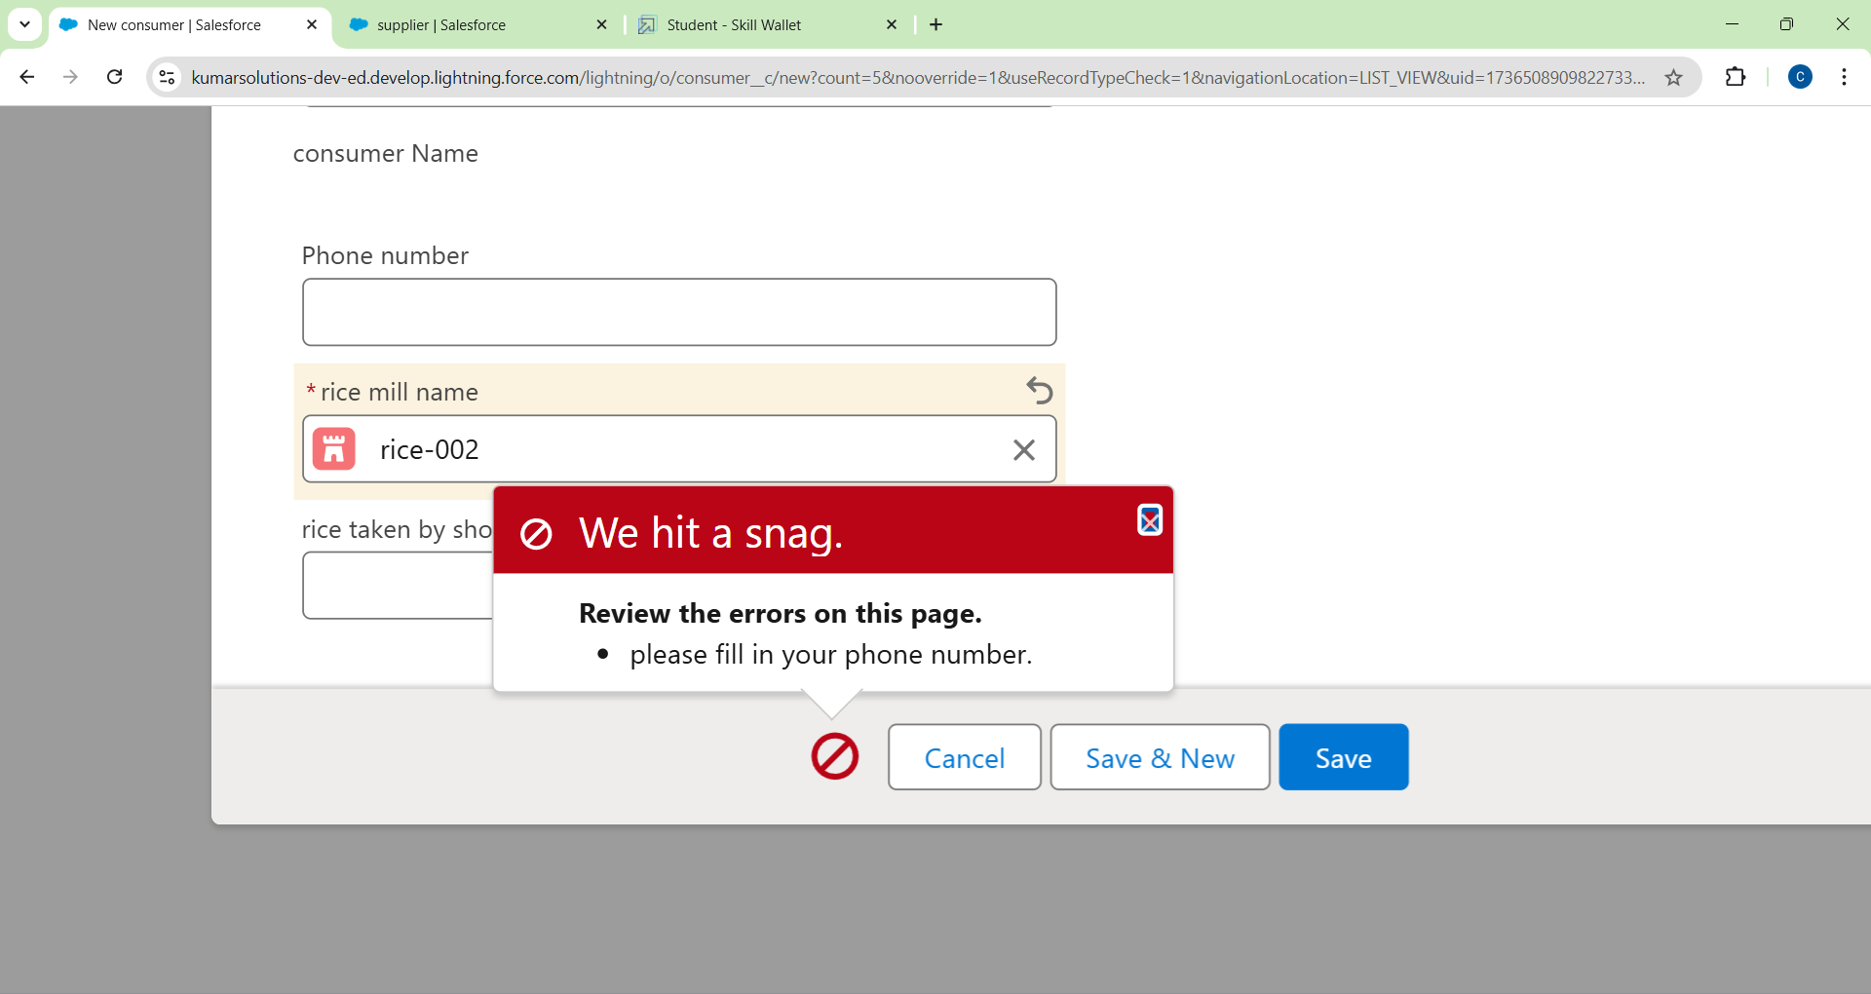

## PAGE LAYOUTS

* Go to Setup >> Click on Object Manager >>Search for the object (consumer) >> From the dropdown, select the object and click on it.
* Click on Page layout >> Click on New.
* Select the existing page layout, and give the page layout name as “consumer layout”, and click save.
* Drag and drop the section field to the consumer details and create the section.
* Enter the section name as “Personal details”, - click Ok.
* Drag the mentioned fields into this section.
* First name, last name, consumer name, phone number, email, rice mill name.
* Follow the same process for another two sections as shown above; they are
* One section is “ rice details ”; drag the fields that are
* Rice taken by the shop, rice type.
* Another section is “Receipt details ”, and drag the fields that are
* Mode of payment, Amount paid.
* Then, Click save.

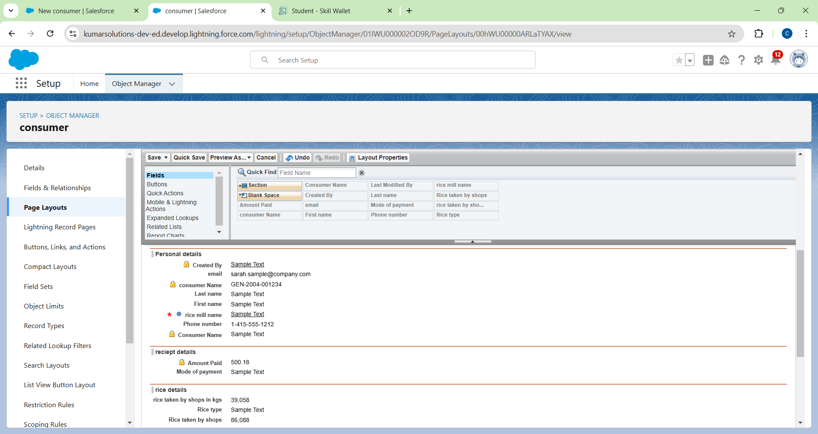

## PROFILES

A profile is a group/collection of settings and permissions that define what a user can do in salesforce. Profile controls “Object permissions, Field permissions, User permissions, Tab settings, App settings, Apex class access, Visual force page access, Page layouts, Record Types, Login hours & Login IP ranges. You can define profiles by the user's job function. For example, System Controller, Programmer, Sales Representative.

**Owner Profile:**

* Go to setup >> type profiles in the quick find box >> click on profiles >> clone the desired profile (Standard User) >>enter the profile name (owner) >> Save.
* Scroll down to Custom Object Permissions and Give access permissions for consumers, rice details, rice mill, and suppliers objects as mentioned in the below diagram.
* Give access and save it**.**

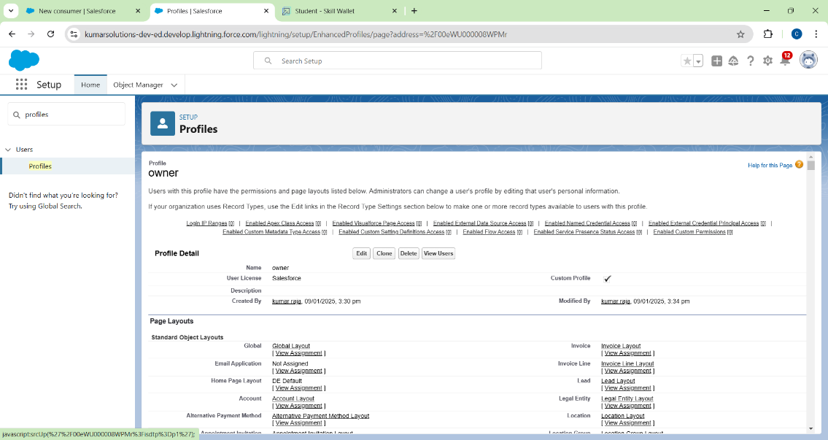

**Employer Profile**

* Go to setup >> type profiles in the quick find box >>click on profiles >> clone the desired profile

(Standard Platform User) >> enter profile name (employer) >> Save.

* While still on the profile page, then click Edit.
* Select the Custom App settings as default for the rice mill.

Scroll down to Custom Object Permissions and Give access permissions for consumer, rice details, rice mill, and suppliers objects as mentioned in the below diagram.

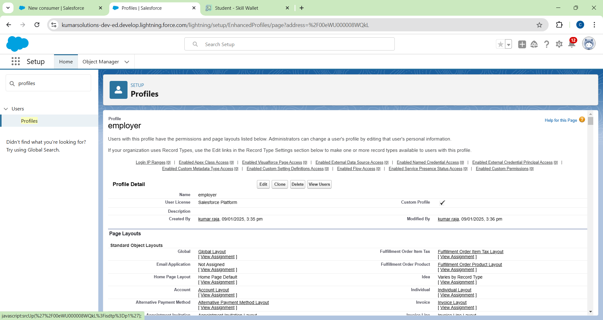

## Worker Profile

* Go to setup >> type profiles in the quick find box >> click on profiles >> clone the desired profile

(Standard Platform User) >> enter profile name (worker) >> Save.

* While still on the profile page, then click Edit.
* Select the Custom App settings as default for the rice mill.

Scroll down to Custom Object Permissions and Give access permissions for consumer, rice details, rice mill, and suppliers objects as mentioned in the below.

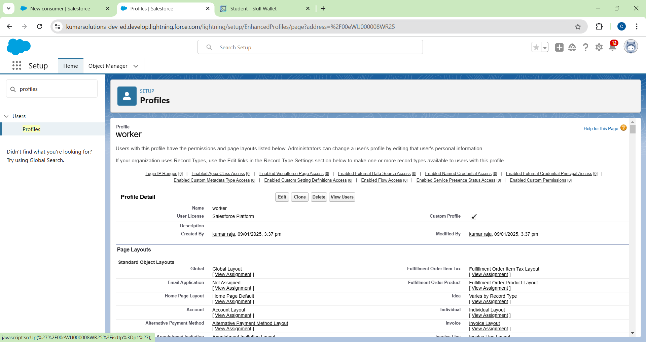

## Role & Role Hierarchy

**Creating owner Role:**

* Go to find Search for Roles quick >> click on set up roles.
* Go to find Search for Roles quick >> click on set up roles.
* Click on Expand All and click on add role under whom this role works.
* Give Label as “owner” and Role name gets auto Filled. Then click on Save.

## Creating employer roles

* Go to find Search for Roles quick >>click on set up roles.
* Click plus on the CEO role, and click add role under owner.
* Give Label as “employer” and Role name gets auto Filled. Then click on Save.
* Repeat the same steps for another role.
* Click plus on the CEO role, and click plus on the owner, and click add role under employer.
* Give Label as “worker” and Role name gets auto Filled. Then click on Save.

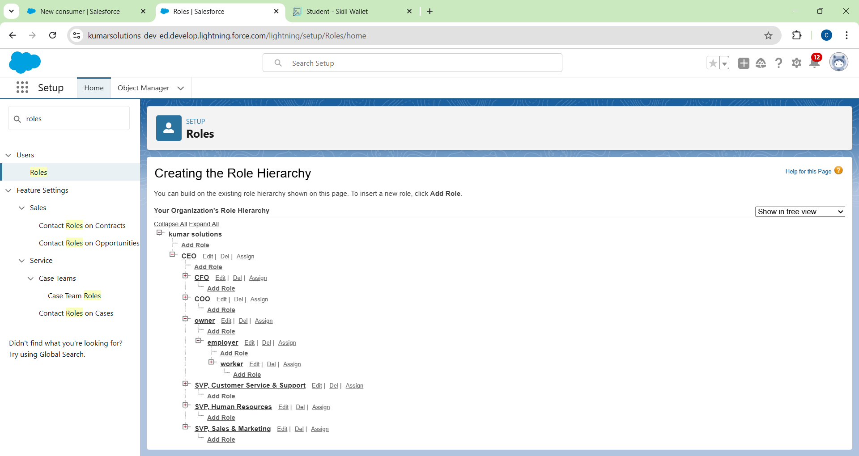

## Report Create Report

* Go to the app >>click on the reports tab
* Click New Report.
* select for report type, search for “rice mill with consumers” and click on it. And click on start report.
* The outline pane is already open; select the fields listed below in the column section.
* 1.consumer name
* 2.rice type
* 3.rice price/kg
* 4.mode of payments
* 5.amount paid
* Remove the Excess fields.
* Select the fields listed below in the **GROUP ROWS** section.
* Rice taken by shops
* Click save and run and save the report as “range of amount per day”.and save it.

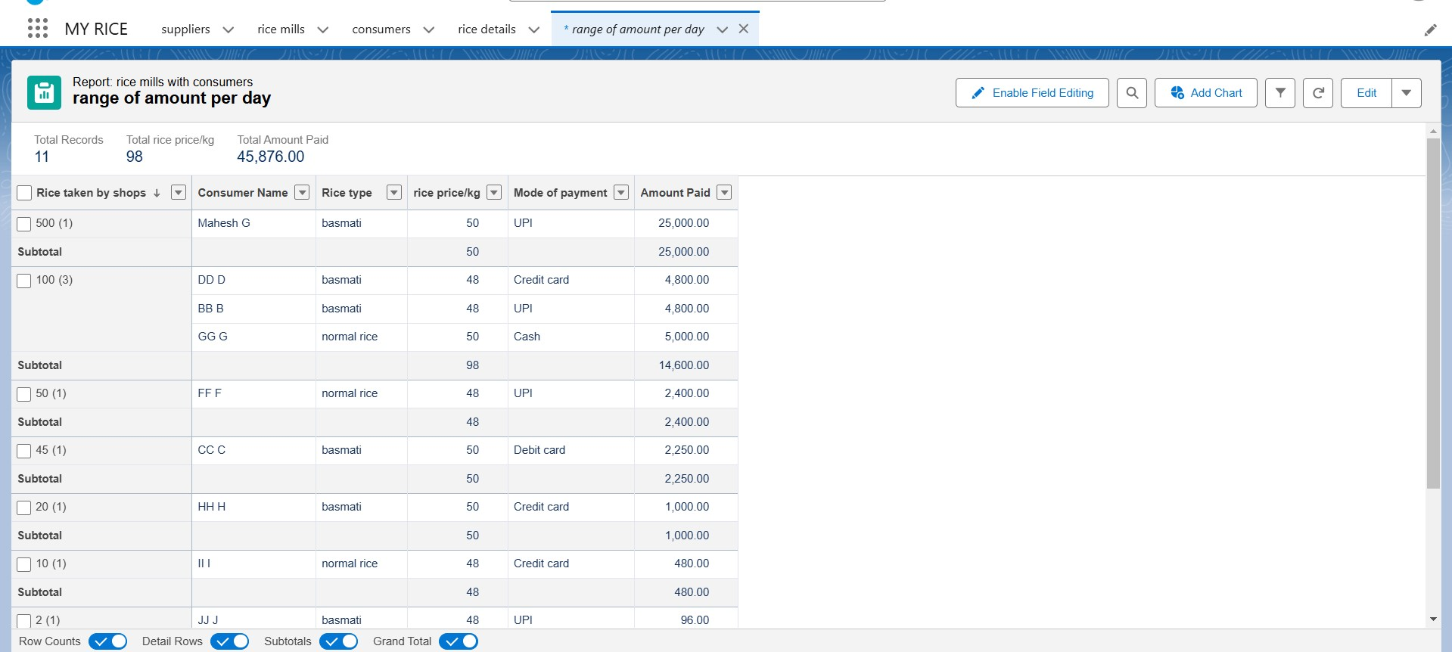

**5. Testing and Check:**

**Creating an Apex Class(ConsumerRecord):**

* Login to the Salesforce account and navigate to the gear account in the top right corner.
* Then we can see the Programmer console. Click on the Programmer console, and you will navigate to a new console window.

* Then you can see many tools in the Toolbar of the new console window. Click on File, New, and Apex Class.
* Enter the name of the class(ConsumerRecord) to create a new class file.

**Code Snippet :** public class ConsumerRecord {

public static void sendEmailNotification (List<consumer__c> con){ for(consumer__c c:con)

{

Messaging.SingleEmailMessage email = new Messaging.SingleEmailMessage();

email.setToAddresses( new List<String>{c.email__c});

email.setSubject('Welcome to our company');

email.setPlainTextBody('Dear ' + customerName + ',\n\n' + 'Welcome to MY RICE! You are recognized as a Important customer to us. Please continue your journey with us as we strive to provide you with high-quality resources.\n\n' + 'Best regards,\n' + 'The MY RICE Team'); 'We are proud to companion with Important customers like you, and we look forward to join forces with you by providing more and more exciting discounts or even product offers too.' + '\n'

+'So why taking a step back, take a leap of faith and shop with us more, while we provide with the Important products and offers'+'\n'+'\n'+'\n'+

'Thankyou for buying '+ '' +'Here are some of the products that are brought by the customers who Likewise bought products like this'+'\n\n');

Messaging.sendEmail(new List<Messaging.SingleEmailMessage>{email});

}

}

}

## Creating an Apex Trigger

While still in the trailhead account, navigate to the gear icon in the top right corner.

Click on Programmer console and you will be voyage to a new console window.

Click on the File menu in the toolbar, and click on new? Trigger.

Enter the trigger name and the object to be triggered.

Syntax For creating trigger :

The syntax for creating trigger is :

Trigger [trigger name] on [object name]( Before/After event) {

//Trigger Logic

**}**

**Code Snippet :** trigger consumerTrigger on consumer__c (After insert) {

if(trigger.isAfter && trigger.isInsert) {

ConsumerRecord.sendEmailNotification(trigger.new);

}

}

**7. Conclusion:**

In conclusion, the Rice Mill CRM App is a comprehensive solution designed to streamline the management of rice production and sales. By automating daily reports on production, sales, and revenue, it provides owners with clear insights into the operational performance of the rice mill. The implementation of customer analytics enables the identification of buying trends and popular rice varieties, enhancing targeted marketing efforts and customer engagement. Additionally, the app’s ability to forecast demand and analyze sales patterns supports efficient resource allocation and inventory management. Overall, the Rice Mill CRM App aims to optimize operations, improve decision-making, and enhance the overall efficiency of the rice mill**.**